Developer Manual
Communication System

Document change log
Rev. | Date | Author | Pages | Description
0 | 2014-06-27 | Artur Scholz | All | Created
1 | 2014-10-13 | Artur Scholz | 7 | Added information

Table of Contents
1 Introduction 3
2 Applicable and reference documents 3
3 Definitions and abbreviations 3
4 Hardware 4
4.1 PCB 4
5 Firmware 5
5.1 Code editing and compiling/linking 5
5.2 Flashing 5
6 Calibration 6
6.1 Frequency and frequency separation calibration 6
6.2 RSSI measurement 6
6.3 Temperature measurements 6

Introduction
This document provides the necessary information for production, assembly and firmware flashing of the product as shown in Illustration 1.

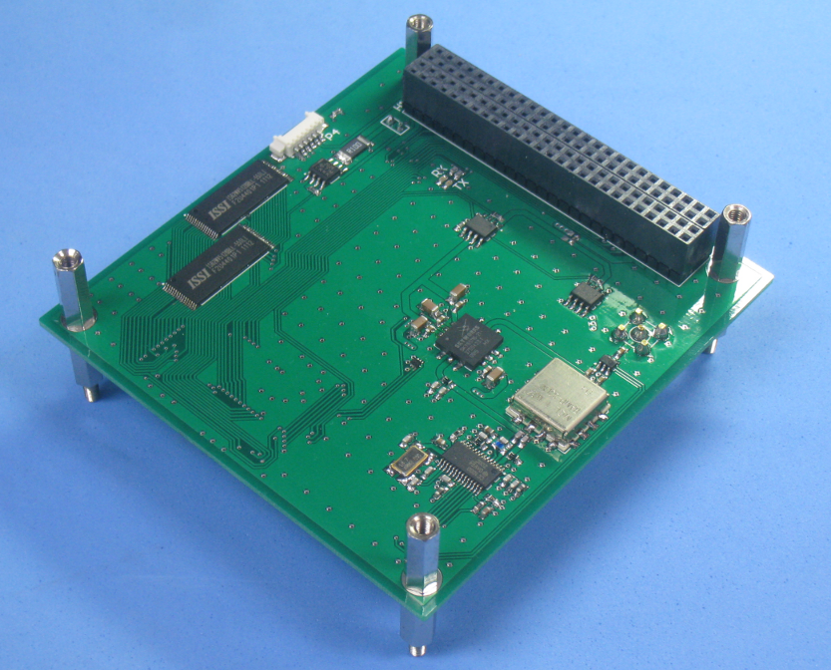Illustration 1: Fully assembled product

Applicable and reference documents

Reference | Title | Issue

Definitions and abbreviations

Abbreviation | Definition

Hardware
The product consists solely of a printed circuit board (PCB) assembly. The bill of materials (BOM) provides the list of items needed for the PCB assembly.

PCB
With the provided Gerber files the double-sided PCB can be produced.

Good PCB layout is crucial to successful working and good performance. The reference layouts for the transceiver and power amplifier were closely followed. A high number of vias was used to interconnect all ground planes. The RF signal tracks to and from the power amplifier were given a width of 3.2 mm (rule of thumb: two times the height of the PCB) to yield 50 Ohm impedance.

The components are hand-soldered onto the PCB. The first part to mount is the high power amplifier (HPA). Attach small dots of solder tin on each pin of the IC and a larger and distributed amount on the center. Do the same for the pads on the PCB (Illustration 2). Key point is to have a solder film on each of the contacts. (It is absolutely important that the center pin has electrical contact!) Place the IC on the PCB and hold it in position with a Kapton tape (Illustration 3). Heat up the solder iron to around 450 °C, and hold it against the center pin vias from the other side of the PCB. Wait several seconds until it becomes apparent that the solder under the IC is liquid, and then remove the iron. In most cases it will be necessary to check the edge pins and solder them again after this procedure.

Illustration 2: Solder tin on pads

Illustration 3: Fixation of HPA chip

Using conductive glue instead of soldering for mounting the HPA is not recommended as it often results in poor conduction. After mounting, check the power amplifier module’s bias current (around 0.350 A without input signal) and output signal levels.

Next to mount is the TR switch, followed by transceiver and filter. Conduct test of the transceiver by checking its frequency range (smaller value for VCO inductor shifts to higher frequency) and check current consumption (in particular check that bias resistor is correct).

Firmware
The firmware is the code that shall be programmed into the microcontroller on the PCB. The firmware has already been compiled and linked and is available as .OMF file for flashing (i.e. programming) of the microcontroller as explained in Section Flashing.

Code editing and compiling/linking
A great and open source compiler for 8051 microcontrollers is SDCC (http://sdcc.sourceforge.net). This is the compiler used for generating the code contained in the repository. Alternatively one can use for example the free KEIL compiler.

As development environment, the author recommends the Eclipse platform with the SDCC plugin. This works great for Linux.

Alternatively, a Windows based IDE is the Silicon Laboratories IDE, which also provides for a debugger.

Flashing
The flashing of the firmware code (as .OMF file) into the microcontroller is done using a USB JTAG Debug Adapter from Silicon Laboratories and the Silabs IDE. This only works with Windows unfortunately.

For the connection of the debug adapter to the device, a small interface board must be used in between, such as the LC-6101a. Alternatively, one can route the wires via a breadboard setup.

Calibration

Frequency and frequency separation calibration
The TX frequency settings should be programmed after the centre frequency and frequency deviation is defined. The 3-byte value to be written in the transceiver register is obtained for a desired frequency according to:

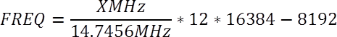
For the TX frequency, replace X with the desired centre frequency minus frequency deviation. For the RX frequency, replace X with the desired centre frequency minus 150 kHz. Also note that although the formula is quite accurate it is necessary to tune the values by hand to obtain a perfect result for each individual device.

For the frequency separation (which is twice the frequency deviation from the centre frequency), the formula for determining the 2-byte register value is:

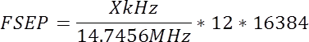

This yields a value of 13.333 for a 1 kHz separation.

RSSI measurement
For calibration of the RSSI measurement, a signal generator shall be connected to the RF terminal. The input signal is set to the frequency and frequency separation as programmed for the transceiver, and its output power is varied, while noting down the RSSI measurements. Obtain gain and offset from a linear least square fitting line.

Temperature measurements
For calibration of the temperature measurements, the device shall be put in a thermally controlled environment, with temperature sensors placed on the temperature measurement locations. The measured temperatures together with the reference measurements shall be noted down for various temperatures. Obtain gain and offset from a linear least square fitting line.

